**SMART STAR EXAMINATIONS BOARD**

**END OF TERM I EXAMINATIONS - 2024**



**LITERACY 1B**

**PRIMARY TWO**

***Time Allowed: 2*** *hours* ***15*** *minutes*

**Name...........................................................Stream............**

**INSTRUCTIONS**

1. ***Avoid unnecessary crossing of work.***
2. ***Use very good handwriting.***

**SECTION A**

1. A ___________________ is a place where we go to learn
2. 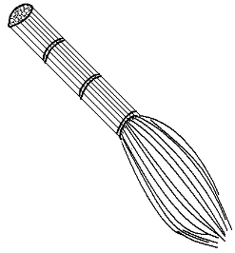How useful is the item below at home**?**

__________________________________________

1. Name one means of road transport.

______________________________________________________

1. Who heads a school**?**

___________________________________________________

1. Write one symbol of a school.

_______________________________________________________

1. Mention one family member you know.

_______________________________________________________

1. Write one person found at school. ______________________________________________________
2. In which district is your school found**?** _______________________________________________________
3. Identify one thing a school can get from the neighbourhood.

_______________________________________________________

1. Name the animal that guards people’s homes. __________________________________________
2. 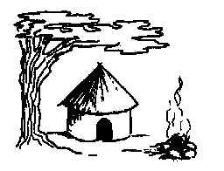Name the house below.

_____________________

1. Circle one type of family

Father, nuclear, grandmother

1. Draw and name one item used in the classroom.

|  |
| --- |
|  |
|  |

1. Write the motto of your school

_______________________________________________________

1. Mention one animal kept at home. _______________________________________________________
2. Name this item used to manage sunny weather.

__________________________________

1. Give one product got from a cow. ________________________________________________________
2. Name one place of worship. ________________________________________________________
3. Write one source of light God created. ________________________________________________________
4. Name any one holy book. _______________________________________________________

**SECTION B (60 MARKS)**

1. Mention two important people in our community.
2. ____________________________________________
3. _______________________________________________
4. A _____________________is a group of people related by blood, marriage or adoption.

(b)

grand parents

_________________

__________________

children

1. Write **yes** or **No**
2. Father cooks food at home ______________________
3. Children fetch water _____________________________
4. Name these buildings found at school.

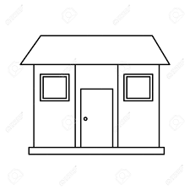

store

___________________________________

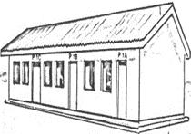

**P.!**

**P.2**

**P.3**

_______________________________

1. Draw these things God created on the 4th day

|  |  |  |
| --- | --- | --- |
|  |  |  |
| sun | moon | stars |

1. Which people pray on:
2. Sunday ___________________________________________
3. Friday ____________________________________________
4. Give two examples of domestic animals created by God.
5. ________________________________________________
6. ________________________________________________
7. 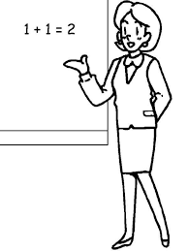Name these people found in the school neighbourhood

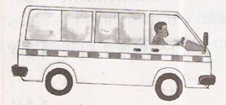

___________________

___________________

1. Write two activities done at school
2. __________________________________
3. ___________________________________
4. Name these building materials.



__________________________________

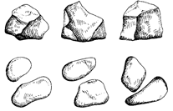

_________________________________

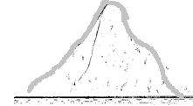

______________________________

1. **Match correctly**

zebra crossing



danger ahead

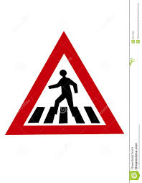

parking

1. (a)Write two sources of water.
2. ______________________________________________
3. _______________________________________________

b. State two uses of water at home.

1. __________________________________________
2. __________________________________________

**END**